ARH 1000 Art Appreciation

Instructor Information
Name: Yarianna Colon-Lopez, M.F.A.
Email: ycolonlopez@valenciacollege.edu
or Directly in Canvas messages box
Office Hours: Virtual appointment, Telephone appointment or scheduled in person
appointments
Credit Hour: 3 credits

Course description:
This course will provide a foundation for understanding the visual arts. It surveys techniques, vocabulary, and the culture influences in the artistic world in contemporary times. Students will explore a variety of visual experiences and examine two and three-dimensional media. Focus will be placed on The Visual Elements, The Principles of Design and understanding art. There is no prerequisite for this course.

Course objectives:
- Students will gain knowledge of the vocabulary used to describe and critique artworks.
- Students will be able to identify art by regional styles, techniques and aesthetic characteristics.
- Students will learn to understand the importance of art.

Course Components:
Course Format
This course is online and it includes weekly assignments. It is essential to abide by the due dates to be successful in this class.

Required Materials
Required Text: The following text is required and must be purchased by each student for successful completion of the course:

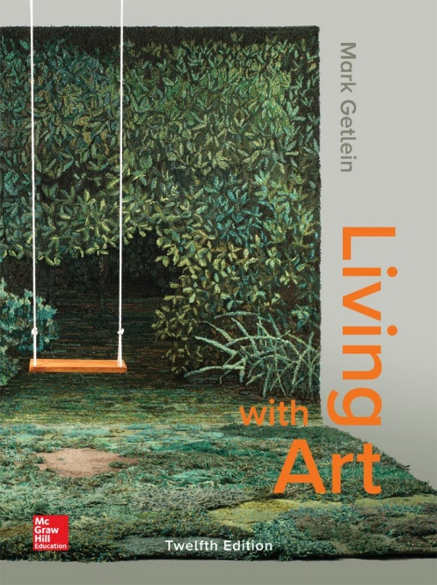
Living With Art by Mark Getlein, 12th edition, ISBN 978-1-259-9167-5 (bound edition)
ISBN 978-1-260-36389-0 (loose leaf edition)
There is a hard cover edition and a loose-leaf edition. It does not matter to me which type of book you purchase and use for the class.
Optional Materials: During the semester we might participate in some activities that will require you to use paper, colored pencils or any art coloring supplies you prefer.

Policies concerning test, quiz and assignment deadlines
• Deadline for taking quizzes and tests: Quizzes and tests must be completed by 11:59 pm each Sunday. Late quizzes are not accepted, after the due date the submission sites will close and they will not be re-opened. Extensions are not automatic; they may be given if a student can offer proof of extenuating circumstances that caused them to legitimately miss a quiz or test deadline. Students are responsible for knowing the due dates for each quiz.
• Deadline for submitting homework assignments: Some homework assignments will be due by 11:59 pm on Fridays, and others will be due by 11:59 pm on Sundays. Students are responsible for knowing the due dates for each assignment. Specific information about each assignment can be found by clicking on "Tasks" at the top of each weekly module. Late homework assignments (not quizzes) will be accepted for one week after their original due date after that the submission site will close and it will not be re-opened. Late homework assignments will be docked with a 15%deduction from the original amount of total points available for the assignment.
Guidelines and Grading Criteria for Discussion Boards
Students are required to post to the Discussion Board on a regular basis, as this is the only way to create a "classroom" atmosphere.
• All original threads should contain a minimum of five (5) complete sentences, and must be posted by 11:59 pm on Friday of the week for which it is assigned. Anyone who does not post their initial thread by the deadline on Wednesday will automatically receive a zero for the Discussion Board, and it will count as an “absence.” (See the Attendance Policy for how “absences”—in the form of missed assignments or discussions—will affect a student’s status in the course.)
• You should respond to the posts of two other students. These responses should each contain a minimum of three (3) sentences (not counting the greeting) and should be posted by 11:59 pm on Sunday of the week for which it is assigned. Please include a greeting that includes the name of the students you are responding to. (Example: "Hi, Katrina. I really like what you said about so-and-so, but here's how I feel about that . . .)
• You must edit your work before posting. If a post contains numerous spelling, grammar or sentence structure errors, no points will be given.
Posts will be graded according to the following criteria:
• Mastery of the subject matter and concepts
• Evidence of strong critical thinking skills through analysis, synthesis, and/or evaluation
• Writing that is clear, edited, articulate, and free of major grammatical errors
• Thoughtful, engaging responses to classmates' posts that enrich the discussion
Attendance and Grading:
The scale is: A=90-100; B=80-89; C=70-79; D=60-69; F=below 60
Attendance is important to successful completion of this class. In an online class, attendance is based on a student's completion of assignments, quizzes, discussion board postings, and tests. A missed deadline for submitting an assignment counts as an absence. After the due date assigned items (whether assignments, discussions, quizzes, or exams) will be closed in the Canvas site and students will no longer be able to access them. If you miss several assignments, these count as absences and you will not have the opportunity to make them up. You will receive a zero on all missing assignments, and those zeros will be calculated into a final letter grade. Students with several missing assignments should consider withdrawing from the class before the withdrawal deadline.
The instructor does not distinguish between "excused" and "unexcused" absences. For severe medical conditions that result in excessive absences, consult the Dean of Students concerning Valencia’s medical withdrawal policy.
Withdrawal due no show period dates: 10/06- 10/15
Projects
There will be two projects in this class. They are called Creative Projects and each of them will count as a grade.

Gradebook
Your grades will be updated regularly. Consult the Grades area on the left to see your current grade in the course (based on the weightings stated above) and specific grades for assignments. There is also an option in the gradebook to determine what your overall grade will be if you earn certain scores on assignments. Please take advantage of this useful tool.
Class points will be given as followed:

Item | Points
2 Test | 100 each
1 Final Exam | 100
2 Creative Projects | 100 each
5 Quizzes | 10 each
10 Discussion Assignments | 10 each
Participation | 100
Total | 750

Academic Honesty:
All students are required to abide by the Academic Honesty Guidelines which have been accepted by the University. For information on what constitutes plagiarism, consult the Student Code of Conduct in the current Valencia Student Handbook.
Students,
Plagiarism is not good. It’s better to hand me a weak writing than a copied one. Effort is valued, plagiarism is dishonest, and it will badly affect your final grade.

For more information, click here Plagiarism

Students with disabilities:
Welcome!
You must have official documentation from the Office for Student with Disabilities (OSD) and submit it to me at the beginning of the semester in order to help me collaborate with your accommodations. The Office for Students with Disabilities determines accommodations based on appropriate documentation of disabilities. The East Campus office is located in Building 5, Room 216.
For more information, visit Office of Students with Disabilities

